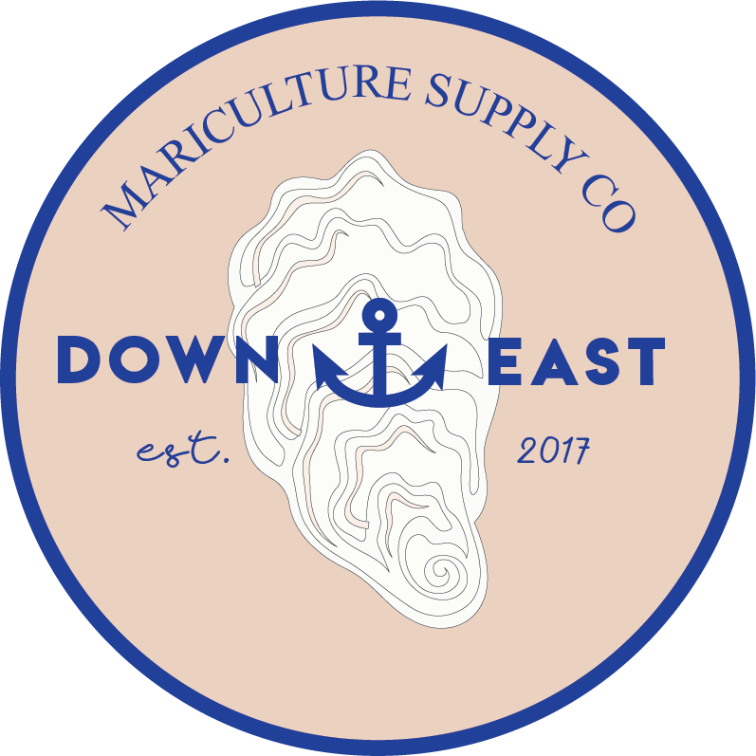
“The Spot for Spat”
586 Hwy 70 Williston
Smyrna, NC 28579
252-204-1134
downeastmariculture.com

Seed Order Form 2026

Name ___________________________________ Company ____________________________________

Mailing Address _________________________________________________________________________

Shipping Address ________________________________________________________________________

Phone _____________________________________ Email ________________________________________

Prices are for triploid oyster seed – DBY’s or Cherrystone. If you prefer a different strain, please call.
A limited number of clam seed will be available in the spring 10-11 mm for $30/1000. Call 252-204-1134 to order clam seed.

Size | Price Per Thousand | Price Per 100,000 | Preference  DBY or CS | Comments
4 mm | $18.00 | $1,800
6.4 mm or 1/4” | $25,00 | $2,500
9.5 mm or 3/8” | $33.00 | $3,300
12.7 mm or 1/2” | $50.00 | $5,000
16 mm or 5/8” | $55.00 | $5,500
19 mm or 3/4” | $65.00 | $6,500

Preferred pick-up or delivery date ___________________________________________________________
Terms:
- Seed orders are filled in the order in which they are received.
- All products must be paid for in full at the time of pick-up.
- A 25% REFUNDABLE* deposit is required. Please make checks out to Down East Mariculture and send them by mail to Susan Hill at PO Box 421, Smyrna, NC 28579.
- Your order is confirmed once you receive an email or text from us.
- Please notify us within 72 hours to assist with count and viability concerns.

Signature ____________________________________ Date_____________________________________

Seed cost $0.10 each for orders under 10,000.

